CUSTOMER BEHAVIOR ANALYSIS

Internship Project Report

Submitted By
Mehak Singh

Internship
InternSpark Summer Internship – Data Analytics

Executive Summary
Customer behaviour analysis plays a crucial role in helping organizations understand purchasing patterns, customer preferences, and retention challenges. This project focuses on analyzing customer transaction data to identify meaningful customer segments, understand purchasing behaviour, and evaluate customer churn trends.
The dataset was cleaned and examined for missing values and duplicate records. Feature engineering techniques were applied to create additional variables that improved the quality of analysis. Exploratory Data Analysis (EDA) was conducted to understand customer demographics, product preferences, payment methods, and purchasing behaviour.
Customer segmentation was performed using K-Means Clustering, resulting in five distinct customer groups. These segments were profiled based on their spending behaviour, purchase quantity, and age characteristics. Churn analysis was also conducted to understand customer retention trends and identify opportunities for improving customer engagement.
The findings of this project provide valuable insights that can help Alfido Tech develop targeted marketing strategies, improve customer retention, and increase overall business performance.

1. Introduction
Customer behaviour analysis plays a crucial role in understanding purchasing patterns, customer preferences, and retention trends. Organizations can leverage customer data to identify high-value customers, improve engagement strategies, and reduce customer churn.
This project focuses on analyzing customer transaction data to identify meaningful customer segments, evaluate purchasing behaviour, analyze churn patterns, and provide actionable business recommendations for Alfido Tech. Machine learning-based customer segmentation using K-Means Clustering was performed to classify customers into distinct groups based on their purchasing characteristics.

2. Project Objectives
The primary objectives of this project are:
- Perform data cleaning and preprocessing.
- Conduct feature engineering to enhance analysis.
- Segment customers using clustering techniques.
- Profile each customer segment.
- Analyze purchase patterns and customer retention trends.
- Identify churn behaviour among customers.
- Provide actionable recommendations to improve customer engagement and business performance.

3. Dataset Overview
The dataset contains customer transaction information including demographic details, purchase behaviour, payment methods, product categories, and churn status.

Dataset Features
Feature | Description
Customer ID | Unique identifier for each customer
Purchase Date | Date of purchase
Product Category | Category of purchased product
Product Price | Price of the product
Quantity | Number of units purchased
Total Purchase Amount | Total transaction value
Payment Method | Mode of payment
Customer Age | Customer age information
Returns | Product return status
Customer Name | Customer name
Age | Customer age
Gender | Customer gender
Churn | Customer retention status

Dataset Size
- Total Records: 202,618
- Total Features: 13

4. Data Cleaning
Data quality assessment was conducted before analysis.

Missing Value Analysis
All columns were examined for null values.
Result:
- No missing values were found in the dataset.

Duplicate Record Analysis
Duplicate transaction records were checked.
Result:
- No duplicate records were identified.

Conclusion
The dataset was found to be clean and suitable for analysis without requiring extensive preprocessing.

Figure 1

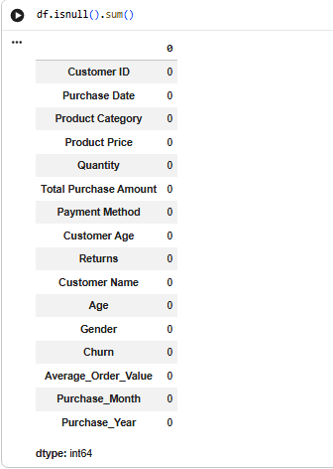

Figure 2
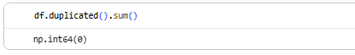

5. Feature Engineering
To enhance analytical capabilities, additional features were created.

Average Order Value
Average Order Value was calculated using:
Average Order Value = Total Purchase Amount ÷ Quantity
This metric helps measure customer spending efficiency.

Purchase Month
The month component was extracted from the purchase date to analyze seasonal purchasing patterns.

Purchase Year
The year component was extracted from the purchase date to facilitate trend analysis.

Benefits of Feature Engineering
- Improved customer behavior understanding.
- Enhanced segmentation quality.
- Better identification of purchase trends.

6. Exploratory Data Analysis (EDA)
Exploratory Data Analysis was performed to understand customer demographics and purchasing behavior.

Customer Age Distribution
The age distribution analysis revealed the presence of both younger and older customer groups, indicating a diverse customer base.

Figure 3

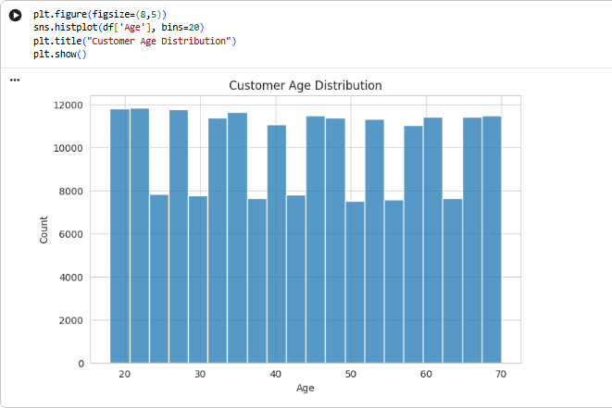

Gender Distribution
Gender analysis helped identify the composition of the customer population.

Figure 4
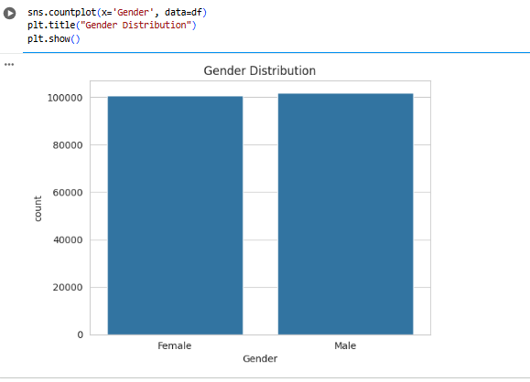

Product Category Analysis
Product category analysis was conducted to identify the most popular categories among customers.

Figure 5
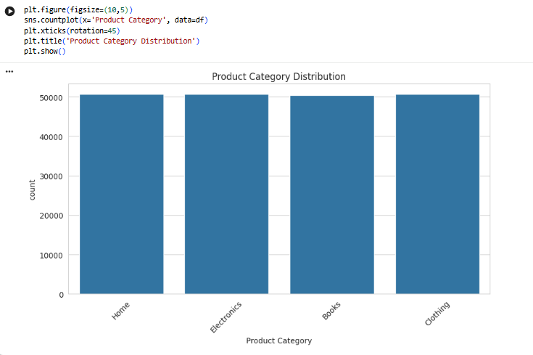

Payment Method Analysis
Different payment methods used by customers were analyzed to understand purchasing preferences.

Figure 6
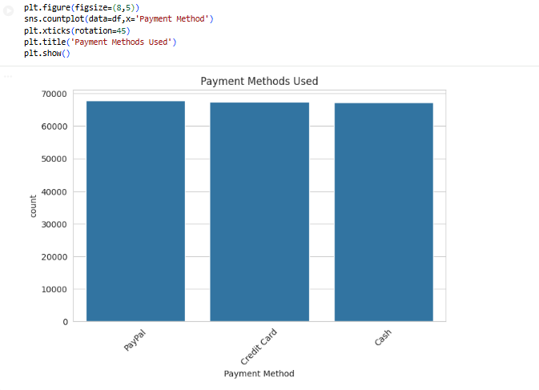

Monthly Purchase Trends
Monthly sales patterns were analyzed to identify periods of high and low customer activity.

Figure 7
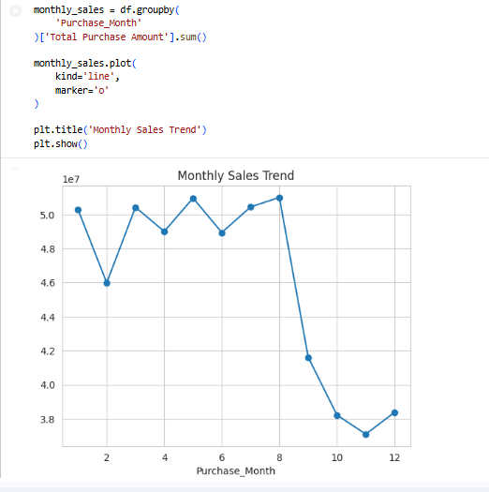

7. Customer Segmentation Using K-Means Clustering
Customer segmentation was performed using the K-Means Clustering algorithm.

Segmentation Features
The following features were used:
- Total Purchase Amount
- Quantity Purchased
- Age
The data was standardized before clustering to ensure equal feature contribution.
The Elbow Method was used to determine the optimal number of clusters.

Figure 8
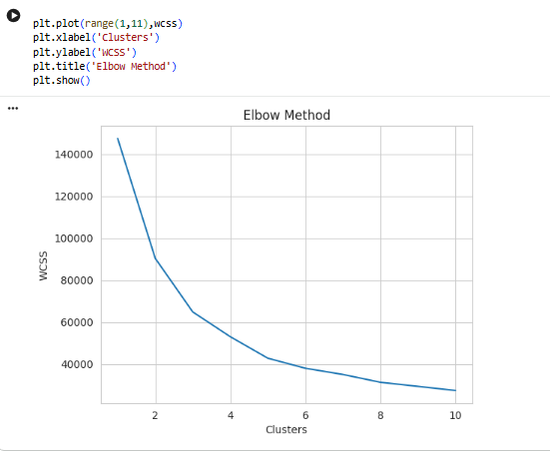
Five customer segments were identified.

8. Customer Segment Profiling
The clustering process produced five distinct customer groups.

Cluster 1 – Premium Customers
Average Purchase Amount: 22,228.84
Average Quantity: 24.02
Average Age: 47.19

Characteristics
- Highest spending customers.
- Highest purchasing frequency.
- Significant contribution to business revenue.

Business Importance
This segment represents the most valuable customer group.

Cluster 0 – Mature High-Value Customers
Average Purchase Amount: 13,475.17
Average Quantity: 14.35
Average Age: 57.41

Characteristics
- High purchasing power.
- Mature customer base.
- Consistent buying behaviour.

Cluster 4 – Young Frequent Buyers
Average Purchase Amount: 13,883.45
Average Quantity: 15.83
Average Age: 29.98

Characteristics
- Young customer segment.
- Frequent purchasing behaviour.
- High growth potential.

Cluster 2 – Young Budget Customers
Average Purchase Amount: 6,553.22
Average Quantity: 7.52
Average Age: 30.40

Characteristics
- Lower spending behavior.
- Price-sensitive customers.
- Responsive to discounts and promotions.

Cluster 3 – Low Engagement Customers
Average Purchase Amount: 6,184.40
Average Quantity: 6.79
Average Age: 56.98

Characteristics
- Lowest spending levels.
- Lowest purchase frequency.
- Higher risk of disengagement.

Figure 9
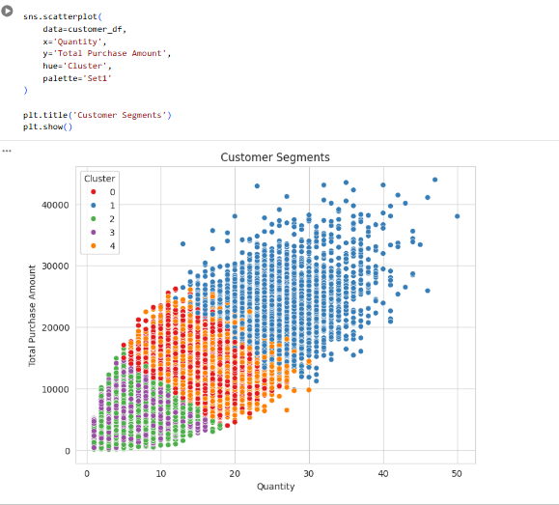

9. Purchase Pattern Analysis
Purchase pattern analysis revealed important customer behavior trends.

Key Findings
- Certain product categories generated significantly higher sales.
- Digital payment methods were widely preferred by customers.
- Younger customers demonstrated higher purchasing frequency.
- Premium customer segments contributed a substantial share of revenue.

Business Implications
Understanding these patterns enables targeted marketing and personalized customer experiences.

10. Retention and Churn Analysis
Customer retention is essential for sustainable business growth.

Churn Distribution

Churn Statistics
- Retained Customers: 161,874
- Churned Customers: 40,744
- Total Customers: 202,618

Churn Rate
Approximately 20.1% of customers were identified as churned.

Interpretation
A churn rate of 20.1% indicates that a significant portion of customers have discontinued engagement, highlighting opportunities for retention strategies.

Churn by Gender
Customer churn behaviour was analyzed across genders to identify retention differences.

Figure 10
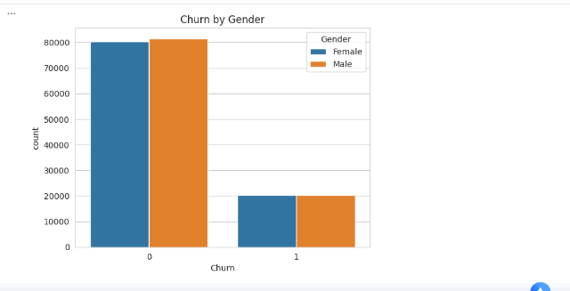

Churn by Product Category
Product category analysis was conducted to determine which categories experience higher churn rates.

Figure 11

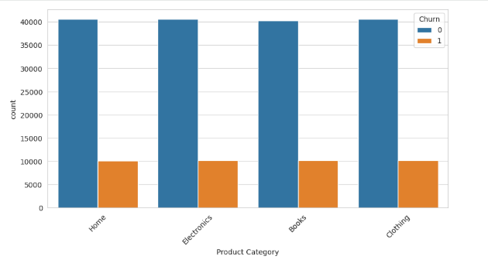

11. Key Findings
The analysis generated several important insights:
- Five distinct customer segments were identified.
- Premium Customers exhibited the highest spending and purchasing frequency.
- Young Frequent Buyers showed strong growth potential.
- Low Engagement Customers demonstrated lower purchasing activity.
- Approximately 20.1% of customers had churned.
- Product categories and payment methods significantly influenced purchasing behaviour.

12. Recommendations for Alfido Tech

Recommendation 1: Launch a VIP Loyalty Program
Develop exclusive loyalty benefits for Premium Customers including rewards, early access, and personalized offers.

Recommendation 2: Implement Customer Retention Campaigns
Target churn-prone customers using personalized email campaigns, discounts, and engagement initiatives.

Recommendation 3: Strengthen Social Media Marketing
Engage Young Frequent Buyers through targeted digital marketing campaigns on social media platforms.

Recommendation 4: Introduce Bundled Offers and Discounts
Encourage Young Budget Customers to increase purchase value through promotional bundles and seasonal discounts.

Recommendation 5: Re-Engage Low Engagement Customers
Use personalized recommendations, surveys, and incentive programs to reactivate inactive customers.

13. Conclusion
This project successfully analyzed customer transaction behavior using data analytics and machine learning techniques. Data cleaning and feature engineering enhanced the dataset, while K-Means clustering identified five meaningful customer segments.
The analysis revealed significant differences in customer purchasing behavior, spending patterns, and retention levels. Premium Customers and Young Frequent Buyers emerged as important revenue-generating segments, while Low Engagement Customers presented opportunities for targeted retention efforts.
The findings and recommendations from this study can help Alfido Tech improve customer engagement, strengthen retention strategies, and support data-driven business decision-making.

Tools and Technologies Used
- Python
- Google Colab
- Pandas
- NumPy
- Matplotlib
- Seaborn
- Scikit-Learn
- K-Means Clustering

References
- Kaggle Customer Behaviour Analysis Dataset
- Python Documentation
- Scikit-Learn Documentation
- Pandas Documentation

